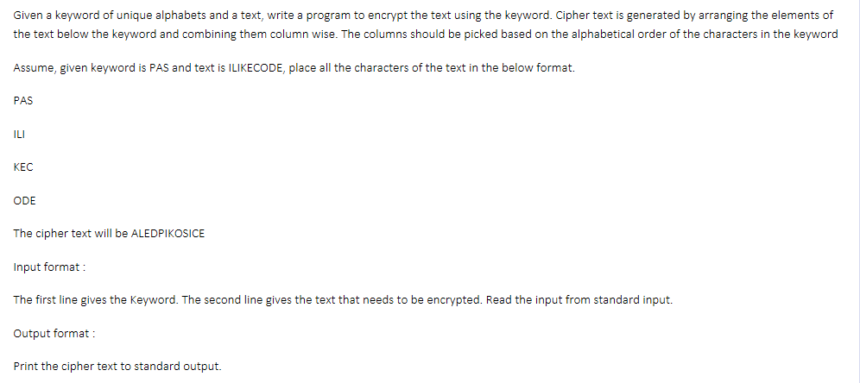

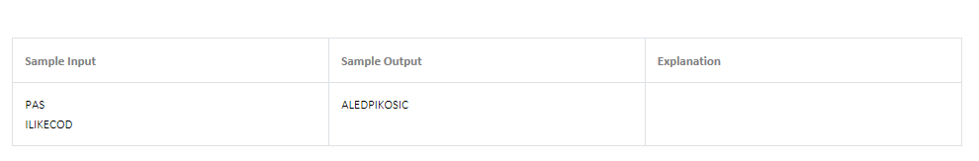

Given a number N having L digits, write a program to find the streak number using the following rules:

1. O=Σ(Ni*2) where Ni represents the digit at odd position and (Ni*2)<L
2. E=ΣNj where Nj represents the digit at even position
3. Streak(S)=k where S is O+E and k is the smallest whole number when S+k is not divisible by k+1

**Input Format**

Read the input from standard input stream

**Output Format**

Print the streak number to the standard output stream

Given a number N having L digits, write a program to find the streak number using the following rules:

1.O=Σ(Ni*2) where Ni represents the digit at odd position and (Ni*2)<L

2.E=ΣNj where Nj represents the digit at even position

3.Streak(S)=k where S is O+E and k is the smallest whole number when S+k is not divisible by k+1

Input Format

Read the input from standard input stream

Output Format

Print the streak number to the standard output stream

|  |  |  |
| --- | --- | --- |
| **Sample Input** | **Sample Output** | **Explanation** |
| 56789112 | 3 | In the given input, the digits 5,7,9 and 1 are at the odd positions and its doubled value correspondingly would be 10,14,18 and 2. 10,14 and 18 are greater than the length of the given input number i.e. 8. Hence O= 2. Similarly, E= 6+8+1+2. Now the S is 19 for which the streak number must be identified. When the value of k=0, 19+0 is divisible by 1+0, when k=1,19+1 is divisible by 1+1, and so on. When k=3, 19+3 is not divisible by 3+1. Hence the streak number for 19 is 3. |
| 98979 | 2 |  |

Given a string S, write a program to print the ASCII value of the character occurring maximum odd number of times.

Input and output format: Read the input string from the standard input stream and print the output to the standard output stream.

|  |  |  |
| --- | --- | --- |
| **Sample Input** | **Sample Output** | **Explanation** |
| AABccdE | 66 |  |
| AAcAbbbbCACC | 67 |  |